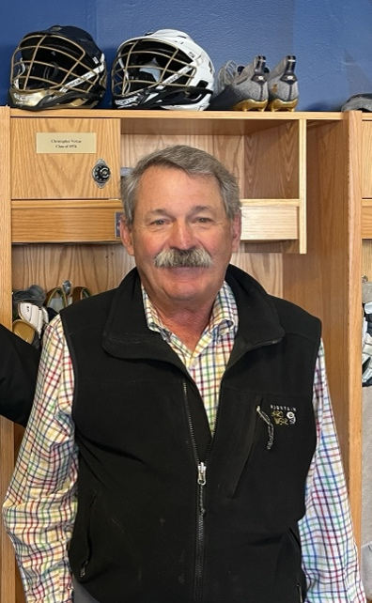

Christopher Frederick Virtue, of Southern Pines, North Carolina, passed away peacefully on June 13, 2024, surrounded by his loving family. Born on December 15, 1950, Chris was a devoted husband, father, grandfather, and faithful servant of the Lord.

Chris is survived by his beloved wife, Kathy Forsigh Virtue, and their cherished children: William Virtue (wife Brianna Virtue) of Virginia Beach, Virginia; Leigh Virtue Stallings (husband Graham Stallings) of Raleigh, North Carolina; Colby Virtue of Nashville, Tennessee; Kate Virtue of Virginia Beach, Virginia; and Ashfod Virtue of Southern Pines, North Carolina. He is also survived by his four beautiful grandchildren: Sloane Virtue, Charlotte Stallings, Emma Virtue, and Gray Stallings, who brought immense joy to his life. Additionally, Chris is survived by his brother Richard Virtue (wife Karliss Virtue) of Charlotte, North Carolina. Chris is preceded in death by his late wife, Charlotte Parish Virtue, his parents, A. William and Claire Virtue, George and Jeanne Parish, and his brother, Peter Virtue, and sister, Kathleen Gavurnik.

A proud graduate of the United States Naval Academy, Chris faithfully served his country with honor and dedication. His time at the Academy and his subsequent service instilled in him a profound sense of duty, loyalty, and commitment that he carried throughout his life. Chris loved playing lacrosse at the Naval Academy, and the friendships he forged there were cherished throughout his entire life. Chris will be honored in the coming months when they dedicate the new Chris Virtue Conference Room as part of the USNA Lacrosse Center.

Chris’ greatest love, however, was for his family. He was a devoted husband and father who cherished every moment spent with his loved ones. His love for his family was unconditional and unwavering, and he took great pride in the achievements and happiness of his wife, children and grandchildren.

Chris' most admirable quality was his unwavering loyalty to friends and family. He was always available to extend a listening ear and offer a word of encouragement. This was particularly demonstrated by Chris and Kathy’s unwavering commitment to honoring his late wife, Charlotte. Chris and Kathy were devoted to the foundation they established in her memory, which helped fund worthy charities and honor her legacy.

In his later years, Chris’s faith in Jesus Christ became the cornerstone of his life. His relationship with the Lord deepened, guiding him through life’s challenges and joys. He found strength in his faith. Chris loved his church, Christ Community Church, and cherished the dear friends he made in his small group.

Outside of his many professional accomplishments, Chris had a passion for golfing with his wife, Kathy, and finding peace and joy with her on the courses of CCNC and Bald Head Island. He relished the camaraderie and the challenge of the game, making many cherished memories with friends and family. Additionally, Chris was an exceptionally graceful skier who loved cruising down the slopes in Snowmass, Colorado with his family. His most cherished memories in Snowmass included his wedding to Kathy and the meaningful conversations he shared with his children on the ski lifts.

Chris’ life was a testament to his faith, love, loyalty and dedication. He leaves behind a legacy of love, kindness, and faith that will continue to inspire and guide his family and friends. While we mourn his passing, we take comfort in knowing that he is now at peace in the presence of our Lord and Savior, Jesus Christ.

A celebration of life service will be held on June 23, 2024, at 2:00 p.m. at Christ Community Church in Pinehurst, North Carolina.

In lieu of flowers, please take a moment to extend a heartfelt thank you to a member of the active military, veteran or first responders’ community. Chris never missed an opportunity to express his gratitude to the men and women who dedicate their lives to serving others.

